Designing the login page

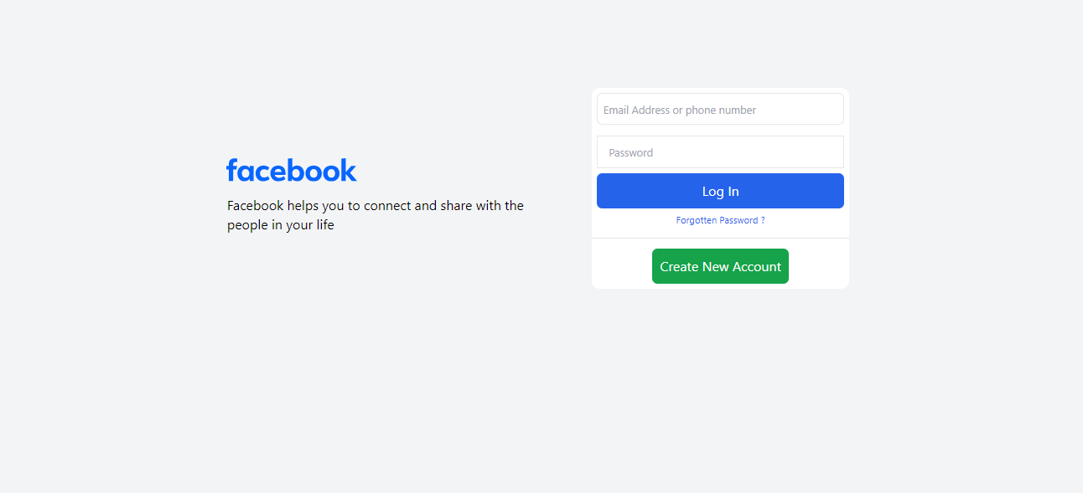

Download **facebook** **logo** image and text from facebook website

Crate main <div>

And two div in it

Use class=”container for main dive”

Left and right for child div

In first div call the image using command <img src="facebooklogo.svg" alt="facebooklogo">

In Right div

create input tap type=”text” with place holder (email address or phone number)

create input tap type=”password” with place holder (password)

Create button with **login** text

Create <span> with Forgotten password text

Add **<hr> tag** for separation.

Add button for **Create New Account**

Add top margin in main div using mt-xxx class utility.

Resize the image using w-xxx utility class.

Make the main div flex using flex tag

Make right div **flex flex-col** to change column layout

Centre the main container by using <div class="container mt-48 flex mx-auto">

To change the background of page add utility class **bg-gray-100** in body element

Change the right side div background to whitel

Align the paragraph with facebook text using utility class in <p> element

Adjust the left div width using utility class **w-xx**

Centre justify and items of the main container div using justify-center and items-center

<div class="container mt-48 flex mx-auto items-center justify-center">

Add margin to left div block by using utility class **mx-xx**

Rounded the right div using tag **rounded-xl** utility class

Border the both input element using border border-1 and border-gray-100 class utilities

Rounded the both input element using rounded-lg utility class

Format the login button using bg-blue-600, text-white, my-2 py-3 rounded-md font-bold utilities classes etc.

Format the Forgotten password ?

Format the “Create New Account” using class utilitis my-2  py-3 bg-green-600 text-white font-bond text-xl rounded-lg w-fit m-auto"

Forgotten Password: Add hover:underline and cursor pointer effect on text

Create New Account: Add hover effect

Hint:

Span and div are both generic HTML elements that group together related parts of a web page. However, they serve different functions. A div element is used for block-level organization and styling of page elements, whereas a span element is used for inline organization and styling